How to Draw Component Diagram?
Component diagram is a kind of UML diagram. shows the physical aspect of an object-oriented software system. It illustrates the architectures of the software components and dependencies between them.

Creating component diagram
Perform the steps below to create a UML component diagram in Visual Paradigm.
- Select Diagram > New from the application toolbar.
- In the New Diagram window, select Component Diagram.
- Click Next.
- Enter the diagram name and description. The Location field enables you to select a model to store the diagram.
- Click OK.

Creating component
To create component in component diagram, click Component on the diagram toolbar and then click on the diagram.
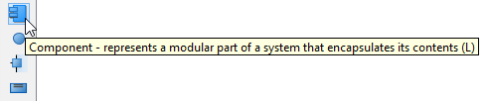
Create component
A component will be created.
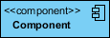
Component created

Assigning stereotypes
Right click on the package and select Stereotypes > Edit Stereotypes... from the pop-up menu.
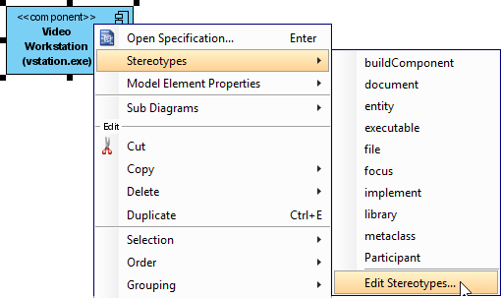
Assign stereotypes
When the Component Specification window is opened, with the Stereotypes tab selected. The list on the left shows the selectable stereotypes.
If the stereotype you want to use is not on the list, click Edit Stereotypes... button.
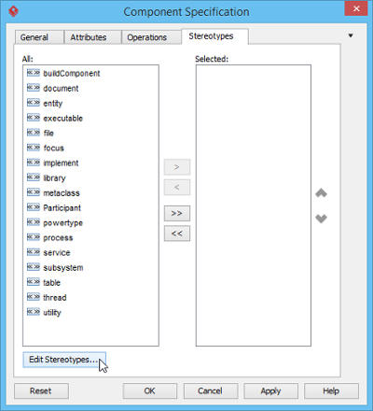
Edit stereotypes
Click Add... button in the Configure Stereotypes window.
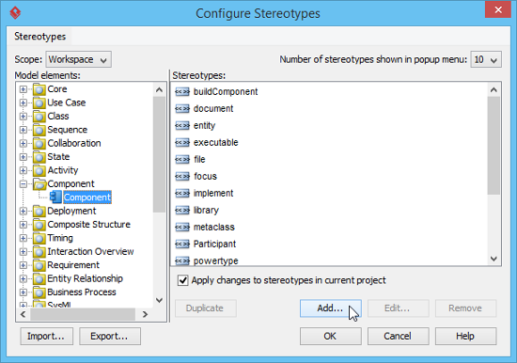
Add stereotype
Name the stereotype (e.g. application) in the Stereotype Specification window and then click OK button to close it. Click OK button in the Configure Stereotypes window. The added stereotype will then be shown on the list in the Component Specification window. Select it and click Add Selected button. Finally, click OK button to confirm.
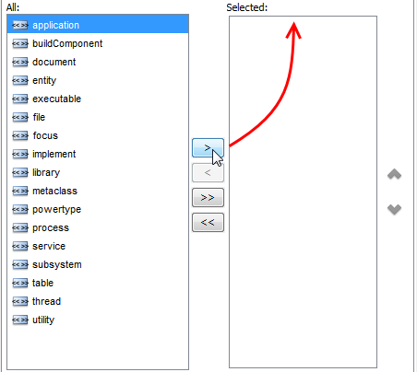
Add selected stereotypes
Close the specification window. Stereotypes will be applied to the package.
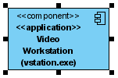
Stereotypes assigned

Creating provided interface
To create provided interface for a component:
- Move your mouse pointer over the source component.
- Press on the Resource Catalog button and drag it out.
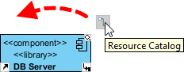
Using Resource Catalog
- Release the mouse button at the place where you want the interface to be created.
- Select Realization -> Interface from Resource Catalog.
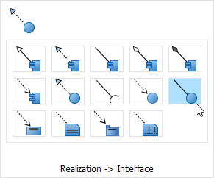
To create a provided interface
- A new interface will be created and is connected to the source component. Enter its name and press Enter to confirm editing.
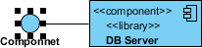
Interface created

Creating required interface
To create required interface for a component, just follow the steps described above for creating provided interface, but change to select Usage-> Interface in Resource Catalog.
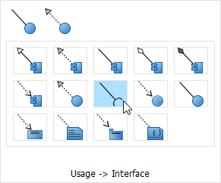
Create required interface

Creating dependency
To create dependency, click Dependency on the diagram toolbar.
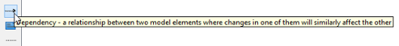
Create dependency
Drag from the source shape, move the mouse over the target shape and then release the mouse button to create the dependency.
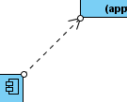
Dependency created
Continue to complete the diagram
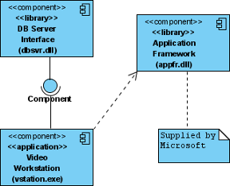
Completed diagram

How to Draw Deployment Diagram?
Deployment diagram is a kind of UML diagram that shows the physical aspects of an object-oriented system. It also shows the configuration of run time processing nodes and artifacts.

Creating deployment diagram
Perform the steps below to create a UML deployment diagram in Visual Paradigm.
- Select Diagram > New from the application toolbar.
- In the New Diagram window, select Deployment Diagram.
- Click Next.
- Enter the diagram name and description. The Location field enables you to select a model to store the diagram.
- Click OK.

Creating node
To create node in deployment diagram, click Node on the diagram toolbar and then click on the diagram.
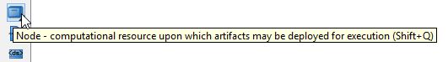
Node selected

Creating instance of node
To create instance of node, click Instance Specification on the diagram toolbar and then click on the diagram.
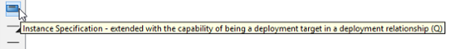
Create instance specification
An instance specification will be created.
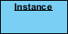
Instance specification created

Selecting classifiers
To specify classifiers for an instance specification, right-click it and select Select Classifier > Select Classifier... from the pop-up menu.
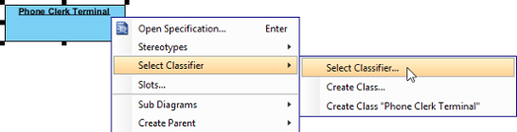
Select classifier
When the Instance Specification Specification window pops out, the Classifiers tab is opened by default. Click Add.... Then, select the classifier(s) in the popup window and click OK.
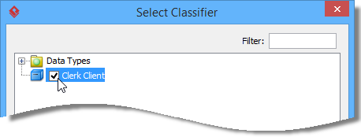
Select node
Click OK button to close the specification window. The selected classifiers are assigned to the instance specification.
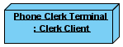
Classifiers assigned

Creating link
To create link from instance specification:
- Move your mouse pointer over the source shape.
- Press on the Resource Catalog button and drag it out.
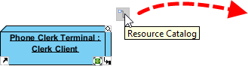
Using Resource Catalog
- Release the mouse button at the place where you want the instance specification to be created.
- Select Link -> Instance Specification from Resource Catalog.
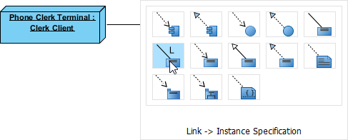
To create an instance specification
- A new instance specification will be created and is connected to the source shape. Enter its name and press Enter to confirm editing.
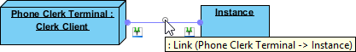
Instance specification created

Creating instance of component
Similar to creating instance of node, you first create a component model element and then create an instance specification. However, this time assigns a component to the instance specification as classifier. After that the instance specification will be displayed as a component.
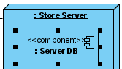
Instance of component

Creating dependency
To create dependency, click Dependency on the diagram toolbar.
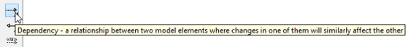
Create dependency
Drag from the source shape, move the mouse over the target shape and then release the mouse button to create the dependency.
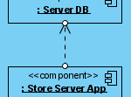
Dependency created
Continue to complete the diagram.
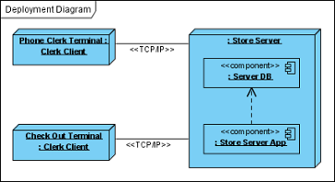
Completed diagram

